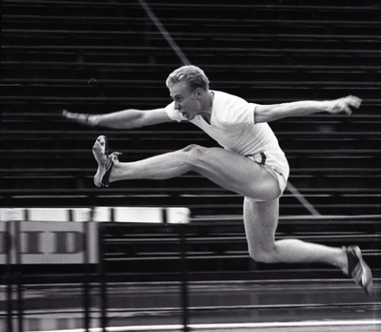https://ajapaik.ee/?album=96670&order1=time&order2=added&page=1
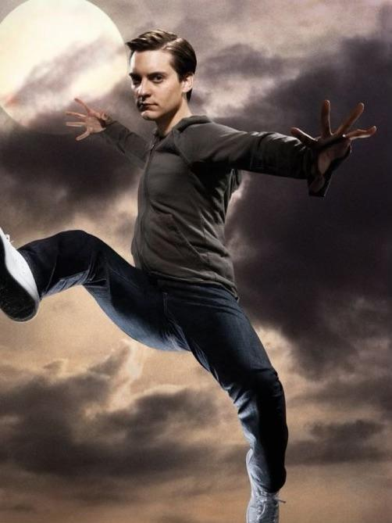https://www.reddit.com/r/raimimemes/comments/177fx11/please_can_anyone_tell_me_the_source_or_history/
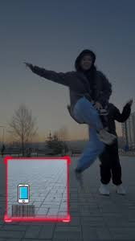
https://www.tiktok.com/discover/dont-get-caught-in-the-frame-filter

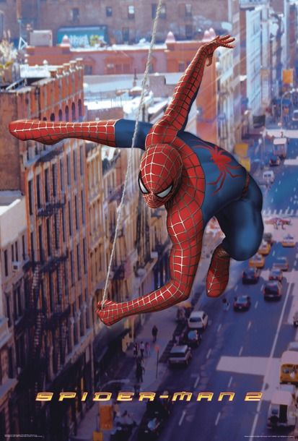
https://www.pinterest.com/pin/714665034615740666/

